Suppose you want to determine if a student is ready to graduate. The 3 criteria for graduation are that the student has earned at least 120 credits, their major GPA is at least 2.0 and their general GPA is also at least 2.0.   
  
Which Boolean expression (next page) would be the correct test for the Python code?

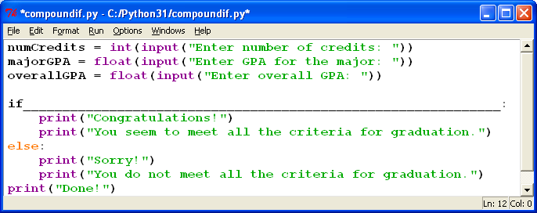

**The Missing Boolean expression is(?)**

a.         numCredits >= 120 or majorGPA >= 2.0 or overallGPA >= 2.0

            b.         numCredits > 120 and majorGPA > 2.0 or overallGPA > 2.0

            c.         numCredits > 119 and majorGPA >= 2.0 and overallGPA >= 2.0

            d.         numCredits >= 120 and majorGPA >= 2.0 and overallGPA >= 2.0

Enter and execute the program in #14. Include your choice for the correct Boolean expression and create several sets of data to test all possibilities for the Boolean expression. List the data you used to test all possibilities for the expression and explain your choices.

| **Data Set** | **numCredits** | **majorGPA** | | **overallGPA** | **Expression Result (True of False)** |
| --- | --- | --- | --- | --- | --- |
| 1 | 80 | | 3.5 | 2.0 | False |
| 2 | 120 | | 2.0 | 2.0 | true |
| 3 | 120 | | 1.5 | 2.0 | false |
| 4 | 120 | | 1.5 | 1.5 | false |
| 5 | 116 | | 1.5 | 1.5 | false |
| 6 | 118 | | 2.2 | 1.5 | false |
| 7 | 116 | | 2.4 | 2.0 | false |
| 8 | 120 | | 2.0 | 1.5 | false |
| 9 | 999 | | 9.0 | 9.0 | true |
| 10 | 69 | | 6.9 | 6.9 | false |